**Sergey Galitsky** is the founder of the largest retail chain ”Magnit”, president and owner of the Russian football club “Krasnodar”.

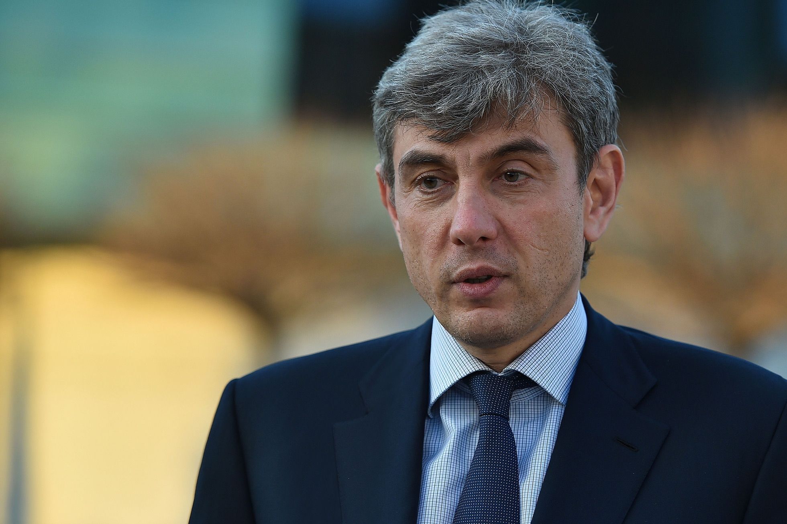

I'm talking about **Sergey** Galitsky. He's a businessman and **patron**.

He enjoys help people. He loves football very much, so he created a football club and built a large arena. There is a large park around it.

Sergey always follows his beliefs and is careful in doing business.

He grew up in Sochi.He has worked in different industries

Now he has retired, and only sometimes gives interviews to journalists.

He has never drunk alcohol, but he has his own vineyards and a winery.

He can play football. At the weekend Sergey with his family goes to the park and cycling on bike, roasts meat, after they come back home. I love him very much!